MECE 6397
Spring 2026
Piero Risi Mortola

Assignment 1
  - Workflow:
- Set up the context of the chat. I have found this is crucial since ChatGPT seems to love giving wordy/winding answers.
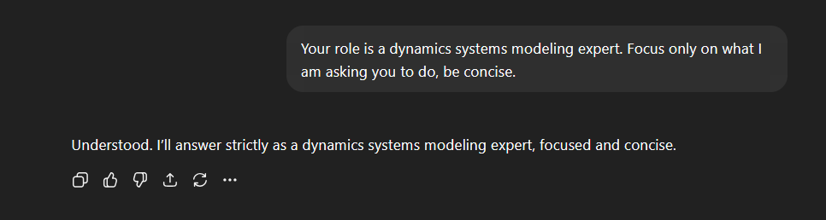
- Give chat a screenshot of the lumped parameter model we will be using. Asked chat to solve for the effective stiffness and mass to cross-reference the expected values.
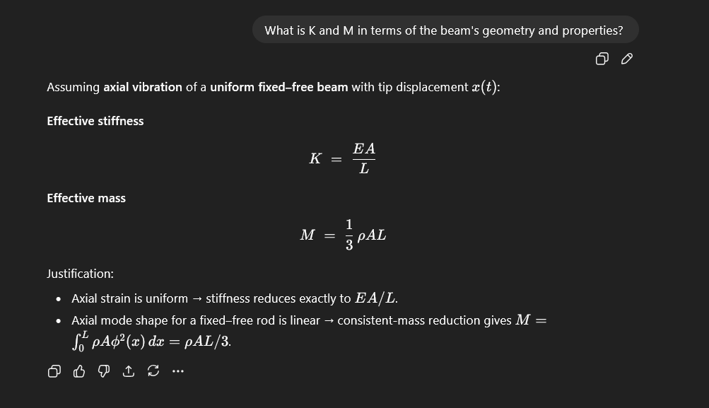

- Asked the chat to solve for the damping coefficient, ζ, and the natural frequency, ω_{n}. Answers match expectations.
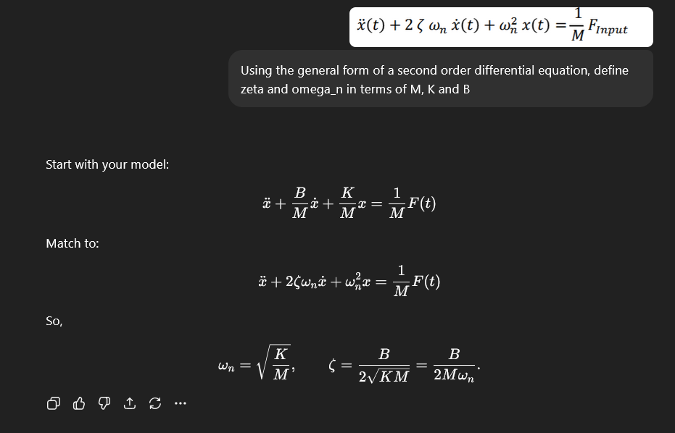
- When checking for any errors, chat keeps track of the assumptions that we have made. It also serves as another way to check whether chat is on the same page.
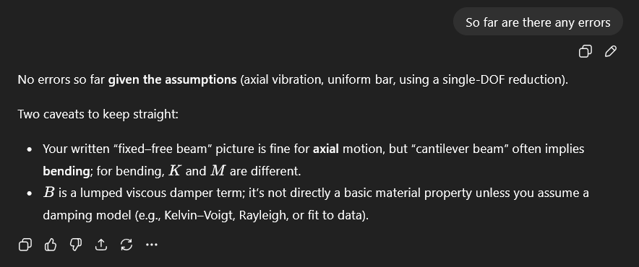
- I then asked it to estimate ζ and B from the plot, using the attached parameters for the beam. It first gave me a different answer than the slides, so I asked it to recheck the peak values. The new results, ζ ≈ 0.046 and B ≈ 5.3x10^3, are close enough to the actual values.
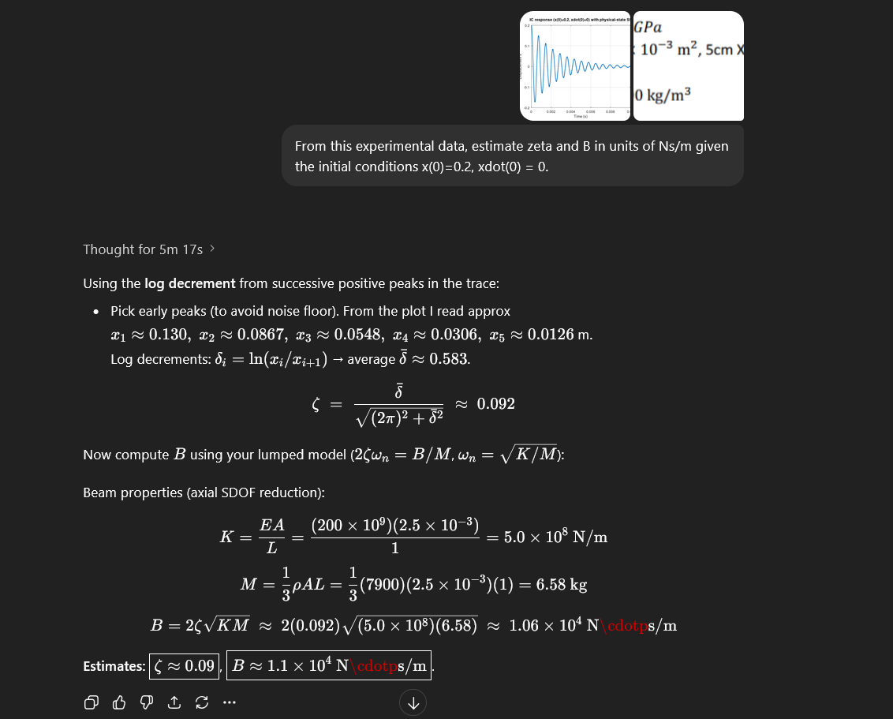
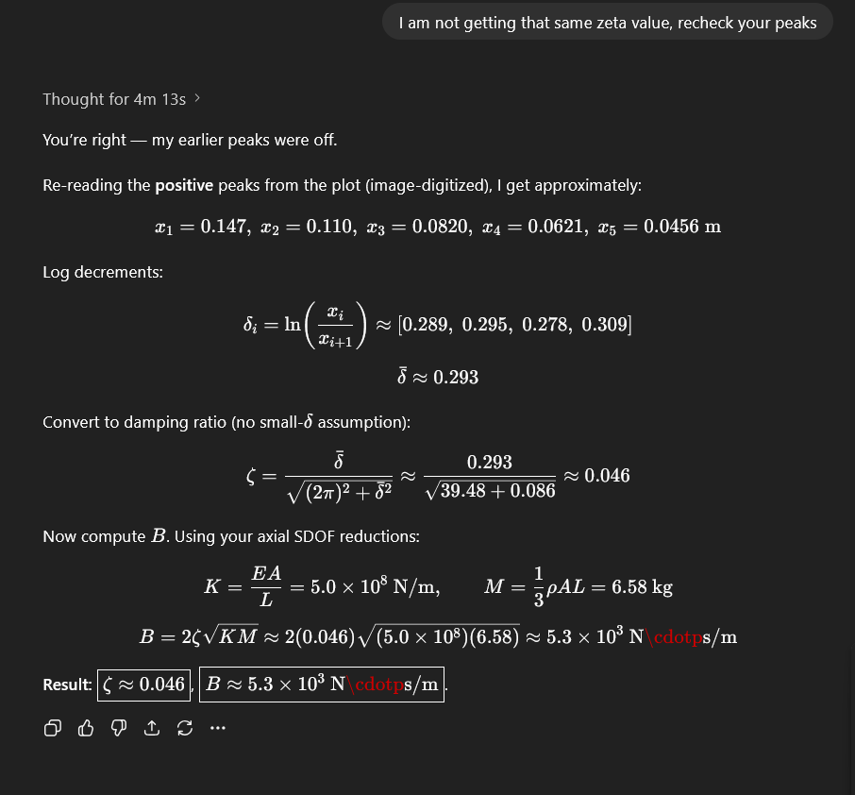

  - MATLAB Code:
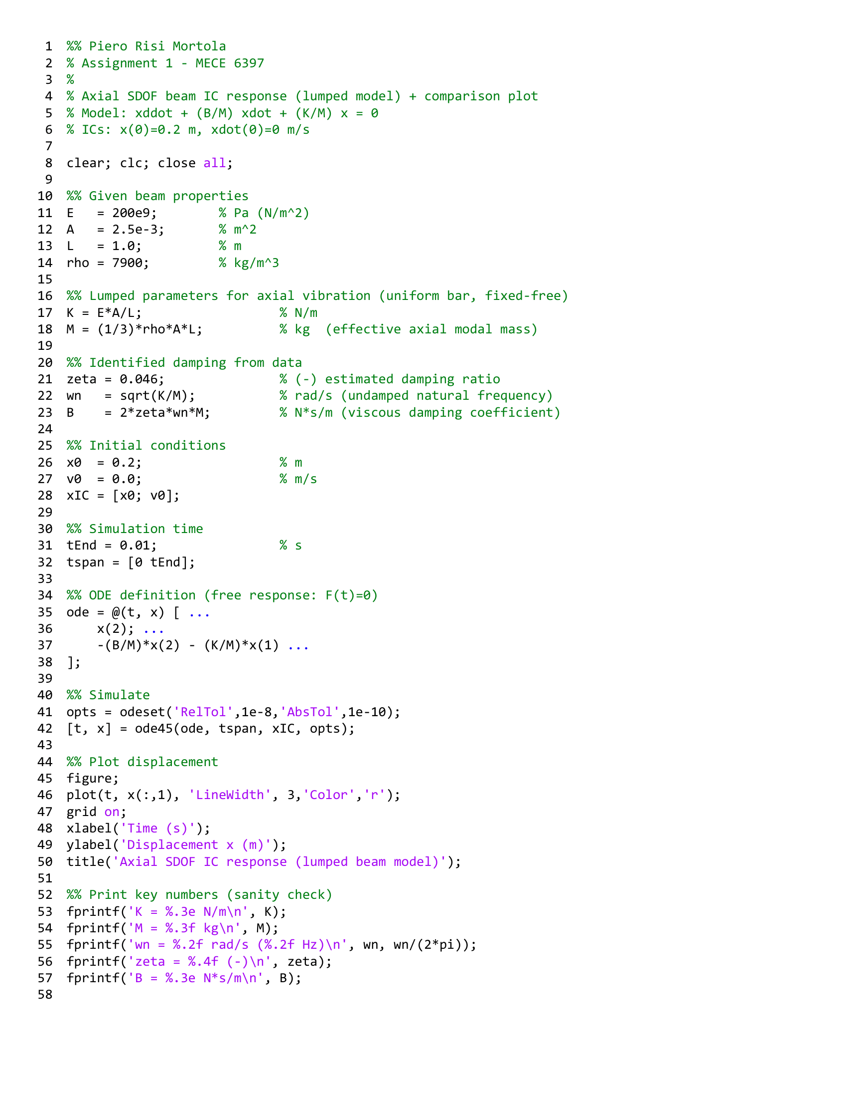

The MATLAB code generated the following plot in red. This is overlayed the plot from the slides and they do match up closely.
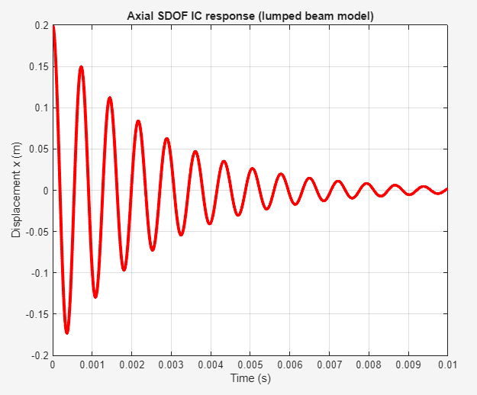
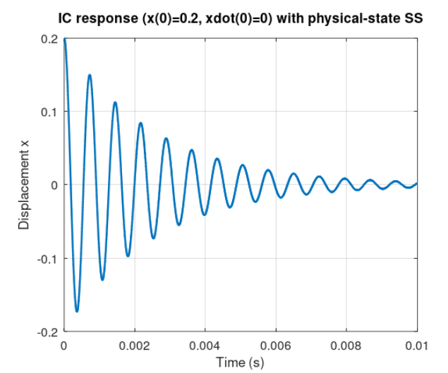

  - Experiences with AI:
- Used for guidance when learning new topics, creating outlines of concepts, etc.
- Have use it to double check work in various projects ranging from tensegrity systems to optimal controls. I have found it tends to go into irrelevant topics.
- When asking for information that I am not familiar enough to tell if what it is saying is correct, I will ask for sources or look up the topic myself. There has been a lot of times that it has been completely off, though it is often because my questions were not worded well enough.
- For this assignment, the generated code used ode45() to run the simulation rather than lsim() in the slides. Probably useful to have the state space representation for later use.

